MACH4METAL

metalworking machinery
Transito 21
6909 DA BABBERICH Netherlands
Tel. +31 (0)316-247123
Fax: +31 (0)316-247956
info@mach4metal.com
www.mach4metal.com

Bank No : 66.52.13.883
IBAN : NL33 INGB 0665 2138 83
BIC : INGBNL2A

CNC Pressbrake 3100 x 200 T
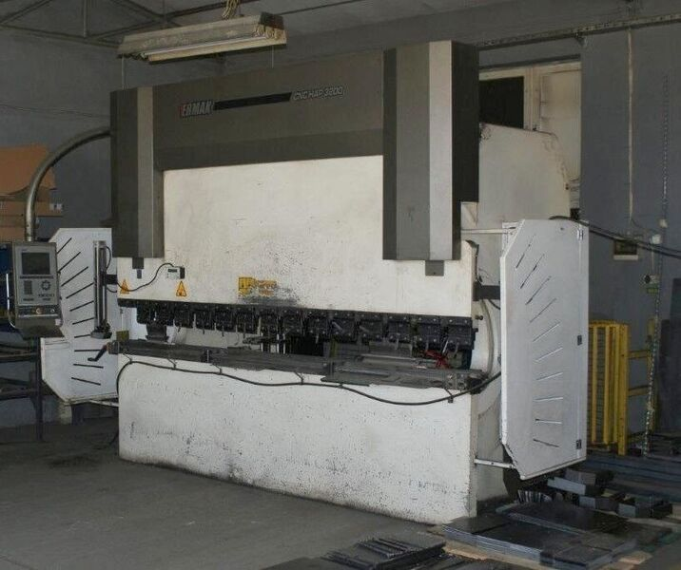
- Make : ERMAKSAN
- Type : CNC HAP
- No : 2007 0205
- Age : 2007

- Max. bending length: 3.100 mm
- Between column : 2.550 mm
- Max. force : 200 Ton

- Beam opening : 435 mm
- Beam stroke : 200 mm
- Table height : 900 mm
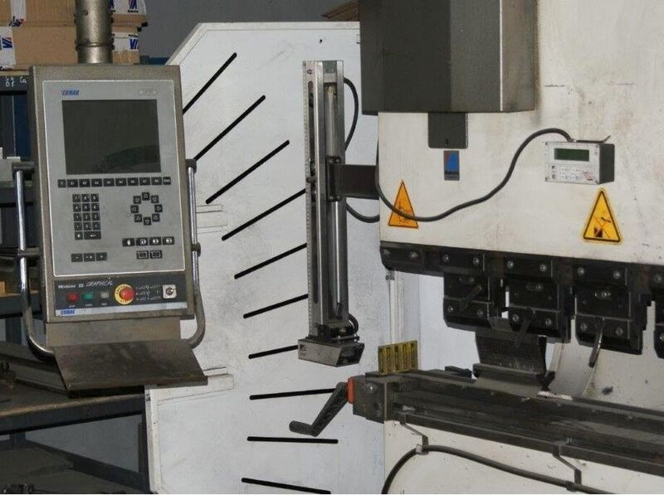
- Troth beam : 400 mm

- Approach speed : 100 mm/sec
- Bending speed : 10 mm/sec
- Return speed : 90 mm/sec

- DELEM DA 70 CNC Control
- Y¹ / Y² / X / R
- 2D Graphical Simulation / Collision
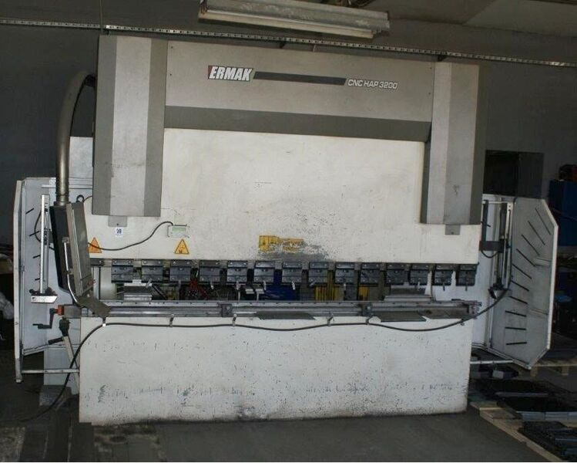
- Dimensions
- Length : 4550
- Width : 2250
- Height : 2850
- Weight : 11.000 Kg
- Power : 15 kW

- Machine is not embedded !
- Build over Floor !
- Hand V Crowning

Please Note: The above information has been obtained to the best of our ability and belief from, and from the manufacturers where possible. It is given in good faith, but its accuracy can not be guaranteed. Accordingly, it will not form a representation or constitute contractual terms. We advise you to check any vital details!

